|  |  |  |
| --- | --- | --- |
| **C:\Users\Dr Zargar\Desktop\download.jpeg** | **ANNUAL ACTION PLAN**  **(2024-25)**  **KVK-ANANTNAG** |  |

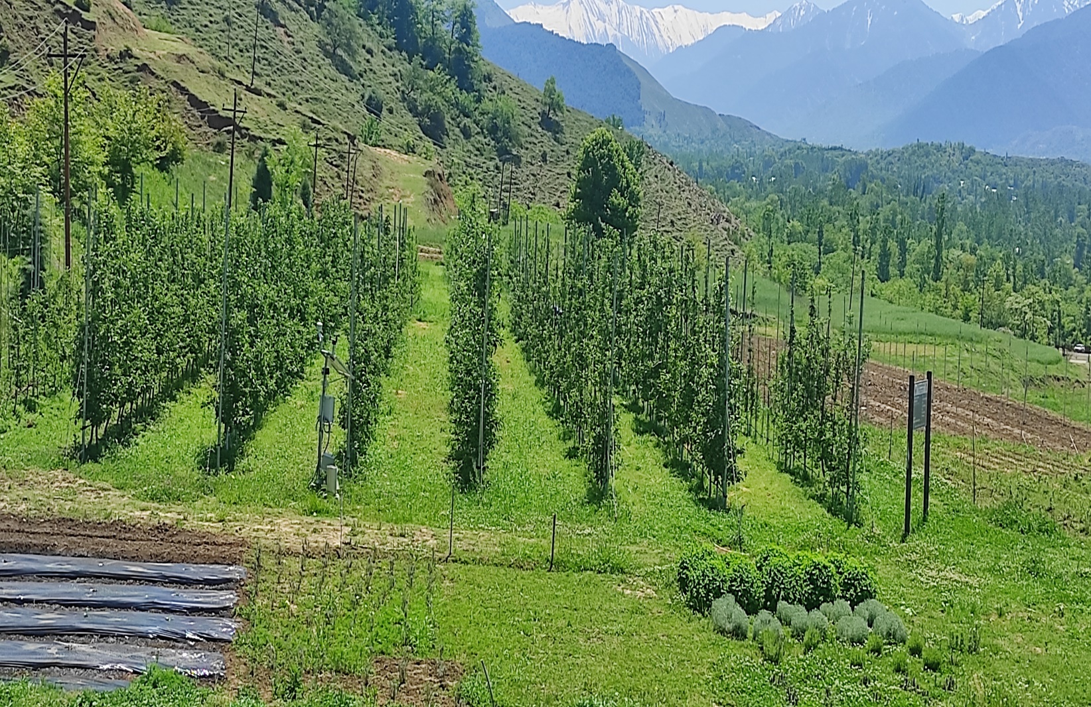

**DIRECTORATE OF EXTENSION**

**SHER-E-KASHMIR UNIVERSITY OF AGRICULTURAL SCIENCES AND TECHNOLOGY OF KASHMIR**

ANNUAL ACTION PLAN

**(2024-25)**

**OF**

# KRISHI VIGYAN KENDRA-ANANTNAG

**Edited and Compiled by: Dr. Ishtiyaq A. Khan**

**Contributors: Dr. Ishtiyaq A. Khan, Dr. Ishtiyak Ahmad Mir, Dr. Shabeer Ahmad Ganaie & Dr. Suheel Ahmad Ganai**

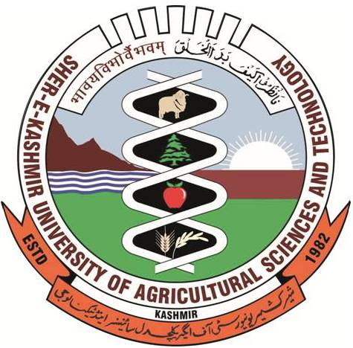

**Directorate of Extension**

**Sher-E-Kashmir University of Agricultural Sciences & Technology-Kashmir**

**Vision & Mission**

* **Mission:** **Empowering farmers and stakeholders through innovative practices, cutting-edge research and comprehensive extension services to ensure sustainable agricultural development and socio-economic progress within our community by fostering Innovations, Entrepreneurship Promotion & Employment Generation.**

**Vision: Empowering KVK to emerge as a dynamic nerve centre, catalyzing the seamless transfer of cutting-edge agriculture and allied technologies, thus evolving into a preeminent resource and knowledge hub. Our vision is to uplift communities by fostering innovation, sustainability and prosperity through the transformative impact of agricultural advancements.**

* Adopting farmer and community centric approach for Holistic Development of Agriculture
* Creating Agri-Business Ecosystem with inbuilt functional value chain
* Support Human Resources Development for technology backup to sustain and accelerate agriculture transformation

**Future Focus Areas**

* Expanding the Cadre of Master Trainers for enhancing capacity building and amplifying its role in agriculture extension and Rural Development
* Impact Assessment of Technological Interventions
* Specialized Skill-Based Trainings.
* Creation and Launching of Innovation Ecosystem
* Training and Handholding of Young Entrepreneurs
* Specialized Women and Tribal Gyan Cell
* Role to Play in District Contingency Plans
* Special Programmes for promotion of Millets (On-campus & Off-Campus)

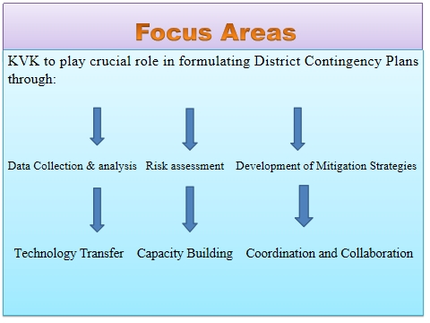

**Thrust Area and Prioritized Problems in Different Sectors**

|  |  |  |  |
| --- | --- | --- | --- |
| **Sector** | **Major Crop/ Enterprise** | **Thrust area** | **Identified Problem** |
| Agriculture | Paddy, Maize,  Oilseed (Mustard) Pulses and Fodder Oats | Enhancement of seed replacement rate, varietal introduction, seed production , Nursery management. INM, IDM and Water Management, | Low Yield,  Low seed replacement rate, Shortage of fodder,  Faulty nutrient application. Increased disease incidence. |
| Horticulture | Apple and walnut | Propagation of quality planting material, rejuvenation through high density orcharding, pollination management, pruning and training and INM. | Faulty training and Pruning, Improper INM, IDM & IPM, Improper plant propagation techniques, Russeting, Monocrop, Lack of pollinizers, Poor quality and yield |
|  | Vegetable and floriculture | Protected cultivation and high value vegetable production . Introduction as novel and remunerative crop. | Lack of quality seed, Lack of knowledge about seed production ,Shortage of vegetables during off season |
| Livestock | Dairy Sheep and goat | Scientific Dairy, Sheep, Goat and Farm management,  Disease and Vaccination management, Nutritional Management during heat and cold stress.  Prevention of early Lamb and kid mortality.  Prevention of mastitis and early calf mortality. | Low milk yield.  Low growth rate.  High mortality in lambs and kids. Prevalent diseases like  Mastitis, Milk Fever, Dystocia, Retained Placenta, Increased parasitic load and repeat breeding.  Shortage of feed and fodder.  Less economical returns.  Lack of interest among rural youth towards livestock enterprise. |
|  | Poultry | Introduction, comparison and management of improved backyard poultry birds. | Low body weight  Low egg production  Low feed conversion efficiency  Low Socio-Economic status |
| Apiculture | Honey Bees | Rearing and management of honey bees | Lack of disease management. Seasonal management. Migration |
| Fishery | Fish Farming | Popularization of cold water fisheries and carp culture | Modification or Degradation of Habitat.  Aquatic Invasive Species (AIS)  Over exploitation of Fish.  Decrease Pollution.  Climate Change. |
| Off Farm | Women empowerment | Cutting and tailoring, knitting of woolies, value addition of fruit and vegetable , tilla embroidery | Decreased interest of rural youths in agriculture & allied enterprises, Lack of orientation on self-employment avenues, Lack of capital for investment |
| Entrepreneurship development. | Rural Youth | Mushroom cultivation and processing, fish farming, value addition of fruit and vegetable and rearing of honey bees | Decreased interest of rural youths in agriculture & allied enterprises, Lack of orientation on self-employment avenues, Lack of capital for investment |
| Natural Resource Conservation | Soil and Water | Soil and Water Conservation | Soil erosion and Moisture deficit |

**Action Plan Aligned with Objectives of HADP for Accelerating Agricultural Transformation**

|  |  |  |  |
| --- | --- | --- | --- |
| **Details of Cluster villages to be adopted during 2024** | | | |
| **Clusters** | **No. of**  **villages** | **Major crops and**  **Enterprises** | **Technological Problems** |
| **I**  **II**  **III**  **IV**  **V** | **12**  **10**  **02**  **05**  **04** | **Paddy, Maize, Pulses, Oilseed, Wheat, Fodder**  **Apple, Walnut**  **Vegetables**  **Livestock &**  **Poultry**  **Machinery (Farm Mechanization & Automation)** | **Abiotic & Biotic Stress, Cold Injury  in Rice, Low SRR & Lack of quality seed in Maize, Lack of INM & IPM, Water Logging in Oilseed, Shortage of**  **Fodder, Lack of Short duration variety in Wheat.**  **Monoculture, Low Productivity, large chunk of old and senile orchards, Lack of quality planting**  **material, poor canopy management.** **Nondescript cultivars (seedling plantation in walnut >90%). Lack of PHM practices**  **Lack of quality seed, lack of knowledge about seed**  **production of high value vegetables, lack of IPM**  **Low milk yield, fodder shortage, lack of quality**  **germplasm, Low egg Production**  **Anticipated labour Crisis during peak season,**  **Efficient utilization of Resources** |

**Proposed Interventions based on Prioritized Problems**

**Gist of OFTs proposed for the year 2024**

|  |  |
| --- | --- |
| **S. NO.** | **Title** |
| 1 | **Assessment of Rice variety Shalimar Sughund-1 (Kashur Basmat) for enhanced  productivity and Profitability** |
| 2 | **Evaluation of Nano Urea sprays for increased yield and economics of Rice** |
| 3 | **Assessment of different Crop Load Management practices for enhanced quality and**  **regularity  in Apple under High density plantation** |
| 4 | **Evaluation of Different Doses  of Indole-3 Butyric Acid (IBA) and Rooting Media on the Rooting of Apple Clonal rootstocks** |
| 5 | **Assessing the Performance of different chemicals for the Management of Necrotic  Leaf blotch (NLB) in Apple** |
| 6 | **Evaluation  of different Chemicals for the Management of Apple Blotch Leaf Miner  (ABLM)** |
| 7 | **Effect of feeding of bypass fat supplementation in dairy cows on Milk Yield.** |
| 8 | **Impact of Winter Chocolates on milk production in dairy cows** |

**Gist of FLDs proposed for the year 2024**

|  |  |  |
| --- | --- | --- |
| **S. No.** | **Title** | **Area**  **(Ha)** |
| 1 | Popularization through Demonstration of High Yielding SR-varieties of Rice suitable suitable for various ecological Niches | **35.0** |
| 2 | Demonstration and Popularization of KG-2 Maize at an elevation of 2000-2600m amsl for Upscaling | **10.0** |
| 3 | Demonstration of SMC-8 and SMC-4 | **10.0** |
| 4 | Demonstration of Hybrid Maize-CFLD | **10.0** |
| 5 | Popularization Demonstration of Shalimar Brown Sarsoan-2 (SS2) for upscaling-CFLD | **50.0** |
| 6 | Demonstration of Soyabean-CFLD | **10.0** |
| 7 | Popularization of  bio-fertilizers (shalimar microbes) in pulses | **10.0** |
| 8 | Demonstration of Fodder Oats | 3.0 |
| 9 | Popularization of Boron and Bouquet Pollination for Improved Fruit set, quality  and yield in Apple | 5.0 |
| 10 | Popularization of Improved Cultivars of Apple through Rejuvenation (Top Working) | 3.0 |
| 11 | Demonstration of Walnut Dehuller | - |
| 12 | Impact of feeding conc. supplementation during transition period in pregnant ewes | - |
| 13 | Popularization of improved varieties of  Backyard poultry birds | - |
| **Total Area (ha)** | | **146+** |

*50 ha. under Oilseed, 10 ha. under Maize, & 10ha. under Soyabeen have been recently sanctioned under CFLD 2024-25 by ICAR

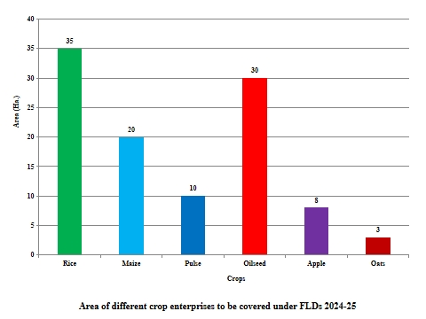

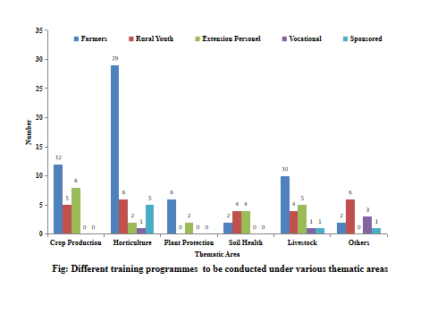

**AGRONOMY & SOIL SCIENCE**

## On- Farm Testing (OFT) during 2024-25.

|  |  |  |  |  |  |  |  |
| --- | --- | --- | --- | --- | --- | --- | --- |
| **Crop** | **Prioritized Problem** | **Title of OFT** | **Technology options** | **Source of technology** | **No of Trials** | **Parameters to be studied** | **Team members** |
| Paddy | Low Yield,  Low seed replacement rate | Evaluation of Shalimar Sugandh-1 (Kashur Basmati) for higher productivity and profitability. | T0= Cultivation of recommended variety  T1= Cultivation of Shalimar Sugandh-1 (Kashur Basmati) with ICM Practices | SKUAST-Kashmir | 03 | Grain Yield (q/ha)  Economics (B:C Ratio) | Dr. S. A. Ganaie, Dr. I. A. Khan, Dr. I. A. Mir |
| Paddy | Loss of nutrient | Effect of Neem Coated urea on NUE and yield of Paddy crop. | T1= Farmers Practice  T2=Use of NCU as single dose (basal dose)  T3= Use of NCU in split doses | SKUAST-K & Literature | 30 | Grain yield (q/ha)  Economics (B:C Ratio) | Dr. S. A. Ganaie, Dr. I. A. Khan, Dr. I. A. Mi |

## Front Line Demonstrations (FLD) during 2024-25

|  |  |  |  |  |  |  |  |  |
| --- | --- | --- | --- | --- | --- | --- | --- | --- |
| **Category** | **Crop/ enterprise** | **Prioritized problem** | **Technology to be demonstrated** | **Source of Technology** | **Name of critical input** | **No. of Demo** | **Parameters to be studied** | **Team members** |
| Cereals | Maize | Low yield | Demonstration and Popularization of KG-2 Maize at an elevation of 2000-2600 m amsl. | SKUAST-K | Seed & Fertilizer | 25 | Yield | Dr. S. A. Ganaie, Dr. I. A. Khan, Dr. I. A. Mir |
|  | Maize | Low yield | Demonstration of Hybrid Maize | SKUAST-K | Seed & Fertilizer | 25 | Yield | Dr. S. A. Ganaie, Dr. I. A. Khan, Dr. I. A. Mir |
|  | Paddy | Low yield | Popularization of High Yielding varieties of Rice - SR4 Plains of District upto an altitude of 1700 m amsl | SKUAST-K | Seed & Fertilizer | 8 | Yield | Dr. S. A. Ganaie, Dr. I. A. Khan, Dr. I. A. Mir |
|  | Paddy | Low yield | Popularization of High Yielding varieties of Rice (SR5) at an altitude of > 2000 m amsl | SKUAST-K | Seed & Fertilizer | 2 | Yield | Dr. S. A. Ganaie, Dr. I. A. Khan, Dr. I. A. Mir |
| Oilseeds | Sarson | Low yield | Demonstration of Shalimar Sarson 2 | SKUAST-K | Seed and fertilizer | 20 | Yield | Dr. S. A. Ganaie, Dr. I. A. Khan, Dr. I. A. Mir |
|  | Sarson | Low yield | Popularization of Sulphur application in Oilseeds for enhanced oil contents | SKUAST-K | Seed and fertilizer | 20 | Yield | Dr. K. A. Sofi, Dr. S. A. Ganaie, Dr. I. A. Khan, Dr. I. A. Mir |
| Pulses | Moong | Low yield | Demonstration of Shalimar Moong | SKUAST-K | Seed and fertilizer | 20 | Yield | Dr. S. A. Ganaie, Dr. I. A. Khan, Dr. I. A. Mir |
|  | Rajamah | Low yield | Demonstration of Shalimar Rajamah (Beans) | SKUAST-K | Seed and fertilizer | 20 | Yield | Dr. S. A. Ganaie, Dr. I. A. Khan, Dr. I. A. Mir |
|  | Pea | Low yield | Demonstration of Shalimar Pea | SKUAST-K | Seed and fertilizer | 20 | Yield | Dr. S. A. Ganaie, Dr. I. A. Khan, Dr. I. A. Mir |
| Soil | Waste Management | Lack of awareness regarding Vermicompost technology | Demonstration of preparation of Vermicompost | SKUAST-K | Earthworms and low cost structure | 03 | Quality parameters | Dr. S. A. Ganaie, Dr. I. A. Khan, Dr. I. A. Mir |

## Training /Awareness/Method demonstration for Farmers/Farm women during 2024-25

|  |  |  |  |
| --- | --- | --- | --- |
| **Training Course Title\*\*** | **No. of Courses** | **Expected No. of participants** | **Names of the team members involved** |
| Integrated management of rice blast | 01 | 25-30 | Dr. S. A. Ganaie, Dr. I. A. Khan, Dr. I. A. Mir & Dr. K. A. Sofi, |
| Integrated Nutrient Management in Field /fruit crops | 02 | 25-30 | Dr. K. A. Sofi, Dr. I. A. Khan, Dr. I. A. Mir & Dr. S. A. Ganaie |
| Role of shalimar biofertilizers. | 02 | 25-30 | Dr. K. A. Sofi, Dr. I. A. Khan, Dr. I. A. Mir & Dr. S. A. Ganaie |
| Balanced application of Fertilizers | 02 | 25-30 | Dr. K. A. Sofi, Dr. I. A. Khan, Dr. I. A. Mir & Dr. S. A. Ganaie |
| Intercropping of Legumes with maize | 01 | 25-30 | Dr. S. A. Ganaie, Dr. I. A. Khan, Dr. I. A. Mir & Dr. K. A. Sofi, |
| Mass awareness regarding the cultivation of millets | 04 | 80 | Dr. I. A. Khan, Dr. I. A. Mir and Dr. S. A. Ganaie |
| Soil sampling techniques for field crops & fruit orchards | 02 | 30-50 | Dr. K. A. Sofi, Dr. I. A. Khan, Dr. I. A. Mir & Dr. S. A. Ganaie |

## Training /Awareness/Method demonstration for Rural Youth during 2024-25

|  |  |  |  |
| --- | --- | --- | --- |
| **Training Course Title\*\*** | **No. of Courses** | **Expected No. of participants** | **Names of the team members involved** |
| Seed production technology and nursery management in Rice. | 01 | 20-25 | Dr. S. A. Ganaie, Dr. I. A. Khan & Dr. I. A. Mir |
| Intercropping of Legumes with maize | 01 | 20-25 | Dr. S. A. Ganaie, Dr. I. A. Khan & Dr. I. A. Mir |
| Role of farm mechanization in crop production | 02 | 20-25 | Dr. S. A. Ganaie, Dr. I. A. Khan & Dr. I. A. Mir |
| Water Harvesting | 01 | 20-25 | Dr. S. A. Ganaie, Dr. I. A. Khan & Dr. I. A. Mir |
| Techniques for collection of leaf and soil samples from different crops and fruits. | 2 | 20-25 | Dr. K. A. Sofi, Dr. I. A. Khan, Dr. I. A. Mir & Dr. S. A. Ganaie |
| Entrepreneurship in vermi Composting (Organic inputs) | 2 | 20-25 | Dr. K. A. Sofi, Dr. I. A. Khan, Dr. I. A. Mir & Dr. S. A. Ganaie |

## Training /Awareness/Method demonstration for Extension Functionaries during 2024-25

|  |  |  |  |
| --- | --- | --- | --- |
| **Training Course Title\*\*** | **No. of Courses** | **Expected No. of participants** | **Names of the team members involved** |
| Post harvest management of vegetables. | 02 | 20-25 | Dr. S. A. Ganaie, Dr. I. A. Khan and Dr. I. A. Mir |
| Entrepreneur opportunities of rural youth | 01 | 20-25 | Dr. S. A. Ganaie, Dr. I. A. Khan and Dr. I. A. Mir |
| Processing and Marketing of Agriculture products. | 02 | 20-25 | Dr. S. A. Ganaie, Dr. I. A. Khan and Dr. I. A. Mir |
| Economic production of field crops | 01 | 20-25 | Dr. S. A. Ganaie, Dr. I. A. Khan and Dr. I. A. Mir |
| Soil Health Management Practices | 01 | 20-25 | Dr. K. A. Sofi, Dr. I. A. Khan, Dr. I. A. Mir & Dr. S. A. Ganaie |
| Scientific techniques of low cost vermicomposting technology | 01 | 20-25 | Dr. K. A. Sofi, Dr. I. A. Khan, Dr. I. A. Mir & Dr. S. A. Ganaie |

## Other Extension Activities during 2024-25

|  |  |
| --- | --- |
| **Extension programme\*** | **No. of programmes or activities** |
| Field Day | 4 |
| Group discussions | 5 |
| Kisan Ghosthi | 4 |
| Method Demonstrations | 1 |
| Exhibition | 4 |
| Exposure Visit | 20 |
| Technology Week | 1 |

**Important Campaigns in collaboration with Line Departments**

* Soil Health Management and Soil Health Card

**HORTICULTURE AND PLANT PROTECTION**

## On- Farm Testing (OFT) during 2024-25.

|  |  |  |  |  |  |  |  |  |
| --- | --- | --- | --- | --- | --- | --- | --- | --- |
| **Crop/ enterprise** | **Prioritized problem** | **Title of intervention** | **Technology options** | **Source of Technology** | **Name of critical input** | **No. of trials** | **Parameters to be studied** | **Team members** |
| Apple | Poor Quality  Biennial Bearing | Assessment of different Crop Load Management practices for enhanced quality and regularity in Apple under High density plantation | T1: No Thinning/Erratic Thinning- (FP)  T2: BA @ 150 ppm + NAA 15ppm (RP)  T3: 6 fruits cm2 TCSA | SKUAST-K | Benzyl adenine (BA) and Naphthalene acetic acid (NAA) | 3 | Quality (% A grade)  Return bloom (No. of flower Culsters) | Dr. I. A. Khan (FS), Dr. K.A. Sofi (SS), Dr. I. A. Mir (AS) and Dr. S. A. Ganaie(AE) |
| Apple | Poor Survival of Hard wood Cuttings of Apple in the Nursery | Evaluation of Different Doses of Indole -3-Butyric Acid (IBA) and Rooting Media on the Rooting of Apple Clonal rootstocks | T0: Farmers Practise –no treatment (F P)  T1 : IBA @ 2500 ppm + Sand: Vermicompost: Cocopeat (1:1:1) (RP)  T2: IBA @ 3000 ppm + Sand: Vermicompost: Perlite (1:1:1) (RP) | SKUAST-K | IBA  Vermicompost,  Cocopeat, Perlite | 3 | Success/Sprouting (%) | Dr. I. A. Khan, Dr. I. A. Mir and Dr. S. A. Ganaie |
| Apple | Leaf Fall  Low Yield  Poor Quality | Assessing the Performance of different chemicals for the Management of Necrotic Leaf blotch (NLB) in Apple | T1: Use of non-specific chemicals (F P)  T2: Soil/Root drenching with Paclobutrazol @ 1ml per year age of the tree + Foliar application of Zinc Oxide (ZnO) @ 0.1% (RP) | SKUAST-K | I.Paclobutrazol 23%SC  II. ZnO | 3 | % Incidence disorder  Yield (Kg/Tree) | Dr. I. A. Khan (FS),Dr. K.A.Sofi (SS)  Dr. I. A. Mir (AS)  Dr. S. A. Ganaie (AE) |
| Apple | Low yield | Assessment of bio fertilizer enriched Vermi-compost application in Apple | T1: RDF  T2: Fertilizer dose on soil test basis  T3: RDF + Vermicompost + PSB + KSB  T4: Fertilizer dose on soil test basis+ Vermicompost + PSB + KSB | SKUAST-K | Bio fertilizer | 3 | Yield  B:C ratio | Dr. K. A. Sofi,  Dr. I.A.Khan |
| Apple | Blotching of Leaves  Leaf Fall  Fruit Fall  Low Yield | Evaluation of different Chemicals for the Management of Blotch Leaf Miner | T1: Farmers practice (FP)  T2: Thiamethoxam 25%WG @50 gm per hundred liters of water + Thiocloprid21.7% SC @   50 ml per 100 litre of water. (RP)  T3:- Imidacloprid + Thiamethoxam@ 50 ml per liters of water (RP) | SKUAST-K | Thiamethoxam 25%WG, Thiocloprid 21.7% SC and Imidacloprid | 3 | % Mortality/Damage  Yield (kg/tree) | Dr. I. A. Khan, Dr. S. A. Ganaie & Dr. I. A. Mir |
| Apple | Burning and wilt of flowers and consequent poor yield. | Evaluation of different chemicals for the Management of Apple blossom thrips in Apple | T1: (FP)  T2:Thiocloprid 21.7% SC @ 0.5 ml per litre of water.  T3 : Dimethoate 30EC@ 1ml per litre of water | SKUAST-K | Thiocloprid 21.7% SC and Dimethoate 30EC | 3 | % Mortality/Damage  Yield (kg/tree) | Dr. I. A. Khan, Dr. S. A. Ganaie & Dr. I. A. Mir |

## Front Line Demonstrations (FLD) during 2024-25

|  |  |  |  |  |  |  |  |  |
| --- | --- | --- | --- | --- | --- | --- | --- | --- |
| **Category** | **Crop/ enterprise** | **Prioritized problem** | **Technology to be demonstrated** | **Source of Technology** | **Name of critical input** | **No. of Demo** | **Parameters to be studied** | **Team members** |
| Horticultural crops | Apple | Poor Fruit set,  Poor Yield and Quality | Popularization of Boron and Bouquet Pollination for Improved Fruit set, quality and yield in Apple | SKUAST-K | Pollinizer Flower Limbs  Boric acid/Solubar | 6 | Yield (Kg/tree)Quality  (% grades) Economics (B:C Ratio) | Dr. I. A. Khan, Dr. I. A. Mir and Dr. S. A. Ganaie |
|  | Apple | Low Yield , Poor quality, less Economic Returns | Popularization of Improved Cultivars of Apple through Rejuvenation (Top Working) | SKUAST-K | Scion wood of Improved apple varieties | 10 | Grafting Success  (%)Annual shoot growth (cm) | Dr. I. A. Khan, Dr. I. A. Mir and Dr. S. A. Ganaie, |
|  | Walnut | Lack of Post harvestManagement Practices, Poor Quality and Returns and Time Consuming/ less efficient | Walnut Dehuller | SKUAST-K |  | 7 | •Efficiency (%)  •Quality and Economic returns | Dr. S. A. Ganaie, Dr. I. A. Khan, Dr. I. A. Mir |

## Training /Awareness/Method demonstration for Farmers/Farm women during 2024-25

|  |  |  |  |
| --- | --- | --- | --- |
| **Training Course Title\*\*** | **No. of Courses** | **Expected No. of participants** | **Names of the team members involved** |
| Layout, Planting and Early care of temperate fruit crops | 03 | 60-80 | Dr. I. A. Khan, Dr. I. A. Mir and Dr. S. A. Ganaie |
| Propagation Techniques in Temperate Fruit crops with special reference to walnut | 02 | 40-55 | Dr. I. A. Khan, Dr. I. A. Mir and Dr. S. A. Ganaie |
| Methods of Fertilizer Application in Apple Orchards | 02 | 40-50 | Dr. I. A. Khan, Dr. I. A. Mir and Dr. S. A. Ganaie |
| Role of Pollinizers/Pollinators in Temperate fruit crops | 03 | 60-80 | Dr. I. A. Khan, Dr. I. A. Mir and Dr. S. A. Ganaie |
| Importance of Mulches in different fruit crops | 01 | 20-25 | Dr. I. A. Khan, Dr. I. A. Mir and Dr. S. A. Ganaie |
| Importance of Micro-Irrigation techniques for enhanced Water Use Efficiency (WUE) in Agri. & Horti crops. | 01 | 20-25 | Dr. I. A. Khan, Dr. I. A. Mir and Dr. S. A. Ganaie |
| Budding Techniques in fruit crops | 02 | 40-50 | Dr. I. A. Khan, Dr. I. A. Mir and Dr. S. A. Ganaie |
| Techniques for collection of leaf samples from apple orchards | 02 | 40-50 | Dr. I. A. Khan, Dr. I. A. Mir and Dr. S. A. Ganaie |
| Scientific techniques of harvesting, grading/packing and truthful labelling in apple | 01 | 20-25 | Dr. I. A. Khan, Dr. I. A. Mir and Dr. S. A. Ganaie |
| Scientific Training and pruning to improve quality and productivity in apple. | 10 | 200-250 | Dr. I. A. Khan, Dr. I. A. Mir and Dr. S. A. Ganaie |
| Awareness Programme on the Importance of High Value and Exotic vegetables. | 01 | 20-25 | Dr. I. A. Khan, Dr. I. A. Mir and Dr. S. A. Ganaie |
| Production management technology of cut flowers. | 01 | 20-25 | Dr. I. A. Khan, Dr. I. A. Mir and Dr. S. A. Ganaie |

## Training /Awareness/Method demonstration for Rural Youth during 2024-25

|  |  |  |  |
| --- | --- | --- | --- |
| **Training Course Title\*\*** | **No. of Courses** | **Expected No. of participants** | **Names of the team members involved** |
| Mass Multiplication of Clonal rootstocks of Apple for Entrepreneurship Development | 1 | 20-25 | Dr. I. A. Khan, Dr. I. A. Mir and Dr. S. A. Ganaie |
| Nursery Raising Techniques in Temperate Fruit Crops | 1 | 20-25 | Dr. I. A. Khan, Dr. I. A. Mir and Dr. S. A. Ganaie |
| Training and pruning to improve quality and productivity in apple with special reference to HDP Apple | 1 | 20-25 | Dr. I. A. Khan, Dr. I. A. Mir and Dr. S. A. Ganaie |
| Post-harvest management of fruits and vegetables | 01 | 20-25 | Dr. S. A. Ganaie, Dr. I. A. Khan & Dr. I. A. Mir |
| Protected cultivation in vegetables | 02 | 20-25 | Dr. S. A. Ganaie, Dr. I. A. Khan & Dr. I. A. Mir |

## Training /Awareness/Method demonstration for Extension Functionaries during 2024-25

|  |  |  |  |
| --- | --- | --- | --- |
| **Training Course Title** | **No. of Courses** | **Expected No. of participants** | **Names of the team members involved** |
| Good Horticultural Practice(GHP) | 1 | 20-25 | Dr. I. A. Khan, Dr. S. A. Ganaie and Dr. I. A. Mir |
| Canopy Management in High Density Apple Orchards | 1 | 20-25 | Dr. I. A. Khan, Dr. S. A. Ganaie and Dr. I. A. Mir |

## Campaigns during 2024-25

|  |  |  |  |  |
| --- | --- | --- | --- | --- |
| **Crop/Entreprise** | **Prioritized problem** | **Training Title** | **No of Demonstrations** | **Names of the team members involved** |
| Apple | Poor Fruit quality and High Disease Incidences | Scientific Training and pruning to improve quality and productivity in apple. | 07 | Dr. I. A. Khan, Dr. S. A. Ganaie and Dr. I. A. Mir |
| Apple | Poor Fruit set and Fruit drop | Pollination Management in Apple. | 07 | Dr. I. A. Khan, Dr. S. A. Ganaie and Dr. I. A. Mir |

**ANIMAL SCIENCES**

## On- Farm Testing (OFT) during 2024-25

|  |  |  |  |  |  |  |  |  |
| --- | --- | --- | --- | --- | --- | --- | --- | --- |
| **Crop/ enterprise** | **Prioritized problem** | **Title of intervention** | **Technology options** | **Source of Technology** | **Name of critical input** | **No. of trials** | **Parameters to be studied** | **Team members** |
| Dairy cattle | Decreased milk production during winter | Impact of Winter Chocolates on milk production in dairy cows | T1: Farmers practice  T2: Winter chocolate 200-250gms/day for 2 month | SKUAST-K | Winter Chocolates | 3 demos  (10 cows each) | Milk yield and BCS | Dr. I. A. Mir, Dr. I. A. Khan and Dr. S. A. Ganaie |
| Dairy cattle | Production problem in early lactation | Effect of feeding of bypass fat supplementation in dairy cows on Milk Yield. | T1: Farmers practice  T2: 20gms of bypass fat /kg milk / animal for -15 to +150 days | NDRI Karnal | Bypass fat | 3 demos (5 cows each) | Milk yield and BCS | Dr. I. A. Mir, Dr. I. A. Khan and Dr. S. A. Ganaie |
| Sheep | Lack of sheep specific mineral mixture | Assessing the performance of Kashvet-S Mineral mixture among sheep breeders of Anantnag. | T1= Farmers Practice  T2= Feeding of 25 grams of Kashvet-S/sheep | SKUAST-Kashmir | Kashvet-S Mineral mixture | 3demo (100 animals each) | Birth weight, Monthly Weight gain, body condition score, wool production | Dr. I. A. Mir, Dr. I. A. Khan and Dr. S. A. Ganaie |

## Front Line Demonstrations (FLD) during 2024-25

|  |  |  |  |  |  |  |  |  |
| --- | --- | --- | --- | --- | --- | --- | --- | --- |
| **Category** | **Crop/ enterprise** | **Prioritized problem** | **Technology to be demonstrated** | **Source of Technology** | **Name of critical input** | **No. of Demo** | **Parameters to be studied** | **Team members** |
| Livestock | Sheep | Early lamb mortality  Less body weight gain | Impact of feeding conc. supplementation during transition period in pregnant ewes | SKUAST-K | Conc. Feed | 3(25 animals each) | Body weight gain, birth weight, mortality if any | Dr. I. A. Mir, Dr. I. A. Khan and Dr. S. A. Ganaie |
|  | Poultry | Low body weight gain, less egg production | Popularization of improved varieties of Backyard poultry birds | SKUAST-K | Birds | 10(50 birds each) | Adult body weight and egg production | Dr. I. A. Mir, Dr. I. A. Khan and Dr. S. A. Ganaie |

## Training /Awareness/Method demonstration for Farmers/Farm women during 2024-25

|  |  |  |  |
| --- | --- | --- | --- |
| **Training Course Title\*\*** | **No. of Courses** | **Expected No. of participants** | **Names of the team members involved** |
| Importance of vaccination in livestock production. | 02 | 40 | Dr. I. A. Mir, Dr. I. A. Khan & Dr. S. A. Ganaie |
| Demonstration on clean milk production. | 01 | 25 | Dr. I. A. Mir, Dr. I. A. Khan & Dr. S. A. Ganaie |
| Demonstration on good quality hay and silage preparation. | 02 | 40 | Dr. I. A. Mir, Dr. I. A. Khan & Dr. S. A. Ganaie |
| Demonstration on value addition of milk and milk products. | 03 | 60 | Dr. I. A. Mir, Dr. I. A. Khan & Dr. S. A. Ganaie |
| Management of backyard poultry birds. | 01 | 25 | Dr. I. A. Mir, Dr. I. A. Khan & Dr. S. A. Ganaie |
| Demonstration on urea treatment of wheat and paddy straw. | 01 | 25 | Dr. I. A. Mir, Dr. I. A. Khan & Dr. S. A. Ganaie |

## Training /Awareness/Method demonstration for Rural Youth during 2024-25

|  |  |  |  |
| --- | --- | --- | --- |
| **Training Course Title\*\*** | **No. of Courses** | **Expected No. of participants** | **Names of the team members involved** |
| Demonstration on preparation of UMMB. | 3 | 20-25 | Dr. I. A. Mir, Dr. I. A. Khan & Dr. S. A. Ganaie |
| Scientific management of commercial poultry farming (broiler production). | 3 | 20-25 | Dr. I. A. Mir, Dr. I. A. Khan & Dr. S. A. Ganaie |
| Scientific Sheep farming: A profitable enterprise | 2 | 20-25 | Dr. I. A. Mir, Dr. I. A. Khan & Dr. S. A. Ganaie |
| Scientific management of profitable fish farming | 3 | 20-30 | Dr. I. A. Mir & Dr. I. A. Khan |

## Training /Awareness/Method demonstration for Extension Functionaries during 2024-25

|  |  |  |  |
| --- | --- | --- | --- |
| **Training Course Title** | **No. of Courses** | **Expected No. of participants** | **Names of the team members involved** |
| Diagnosis of some economically important diseases in sheep | 1 | 20-25 | Dr. I. A. Mir, Dr. I. A. Khan and Dr. S. A. Ganaie |
| Diagnosis and treatment of reproductive diseases in dairy cows. | 1 | 20-25 | Dr. I. A. Mir, Dr. I. A. Khan and Dr. S. A. Ganaie |
| Nutritional Management of dairy cows and sheep during winter. | 4 | 80-90 | Dr. I. A. Mir, Dr. I. A. Khan and Dr. S. A. Ganaie |
| Diagnosis and management of milk fever in dairy cows. | 4 | 80-90 | Dr. I. A. Mir, Dr. I. A. Khan and Dr. S. A. Ganaie |
| Awareness on IFS: A way towards sustainable agriculture | 4 | 80-90 | Dr. I. A. Mir, Dr. I. A. Khan and Dr. S. A. Ganaie |

**Other Extension activities**

Animal Diagnostic visits: Need Based

Animal clinical camps: Two mega animal clinical camps

Need based awareness and training programmes

Celebration of special days.

World veterinary Day: last Saturday of April.

World Milk day: 29th May

World Environment Day: 5th June

World Zoonoses Day: 6th July

National Nutrition Week 1-7th September

World Rabies day: 28th September

World egg day: 12th October

World hug a sheep day: 28th October.

Farmers Day: 23rd December.

World Soil day 5th December

## Proposed Extension programmes during 2024-25

|  |  |  |
| --- | --- | --- |
| **Extension programme\*** | **No. of programmes or activities** | **Names of the team members involved** |
| Advisory Services | > 120 (Need based) | All Scientists |
| Field Diagnostic visits | Need Based |
| Field Day | 08 |
| Group discussions | Need Based |
| Kisan Ghosthi | Need Based |
| Film Show | Need Based |
| Self -help groups | Need Based |
| Kisan Mela | 2 |
| Exhibition | Need Based |
| Scientists' visit to farmers field | Need Based |
| Plant/Soil health/Animal health camps | Need Based |
| Farm Science Club | Need Based |
| Ex-trainees Sammelan | Need Based |
| Farmers' seminar/workshop | Need Based |
| Method Demonstrations | 34 |
| Celebration of important days | Need Based |
| Exposure visits | Need Based |
| Technology week, | Need Based |
| Farm innovators meet | Need Based |
| Awareness programs | Need Based |
| Others, pl. specify |  |

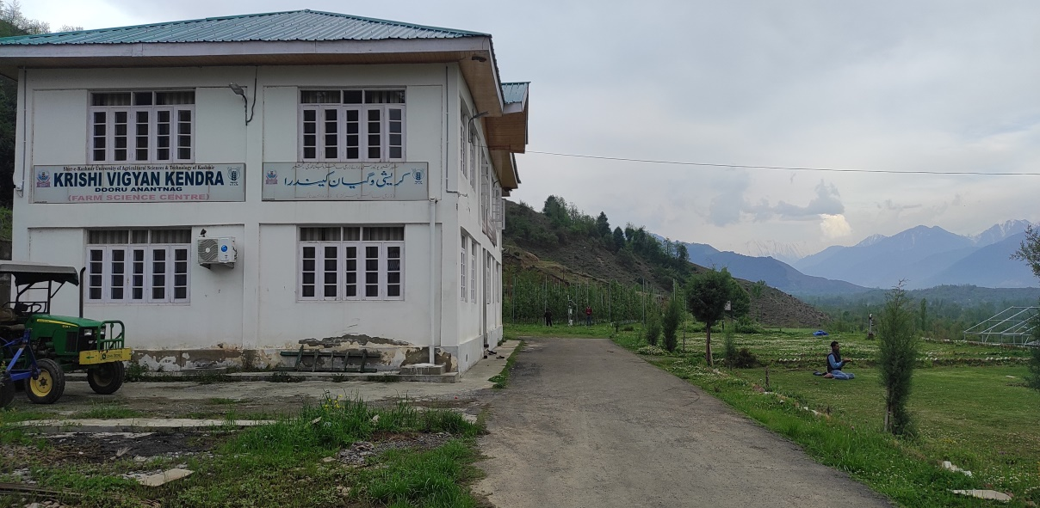

|  |  |
| --- | --- |
|  | C:\Users\Dr Zargar\Desktop\1715936551113.jpg |

